EX. NO: 1
IMPLEMENTATION OF CAESAR CIPHER

AIM:
To implement the simple substitution technique named Caesar cipher using C language.
DESCRIPTION:
To encrypt a message with a Caesar cipher, each letter in the message is changed using a simple rule: shift by three. Each letter is replaced by the letter three letters ahead in the alphabet. A becomes D, B becomes E, and so on. For the last letters, we can think of the alphabet as a circle and "wrap around". W becomes Z, X becomes A, Y becomes B, and Z becomes C. To change a message back, each letter is replaced by the one three before it.
EXAMPLE:
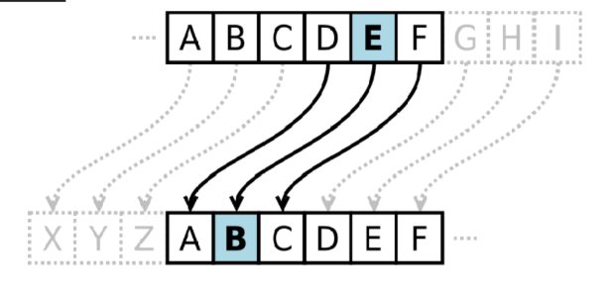

ALGORITHM:
STEP-1: Read the plain text from the user.
STEP-2: Read the key value from the user.
STEP-3: If the key is positive then encrypt the text by adding the key with each
character in the plain text.
STEP-4: Else subtract the key from the plain text.
STEP-5: Display the cipher text obtained above.
PROGRAM: (Caesar Cipher)
def encrypt(text, key):
cipher = ""
for ch in text:
if ch.isalpha():
if ch.isupper():
cipher += chr((ord(ch) - ord('A') + key) % 26 + ord('A'))
else:
cipher += chr((ord(ch) - ord('a') + key) % 26 + ord('a'))
else:
cipher += ch
return cipher
def decrypt(cipher, key):
text = ""
for ch in cipher:
if ch.isalpha():
if ch.isupper():
text += chr((ord(ch) - ord('A') - key) % 26 + ord('A'))
else:
text += chr((ord(ch) - ord('a') - key) % 26 + ord('a'))
else:
text += ch
return text
plain_text = input("Enter the plain text: ")
key = int(input("Enter the key (shift value): "))
cipher_text = encrypt(plain_text, key)
print("Encrypted Text :", cipher_text)
decrypted_text = decrypt(cipher_text, key)
print("Decrypted Text :", decrypted_text)

OUTPUT:
